OUTPUT
Challenge 1 : student name formatting
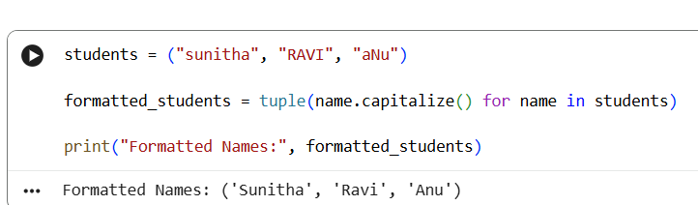
Challenge 2: count total subjects
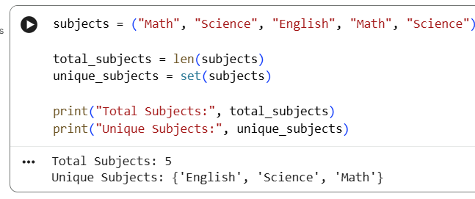
Challenge 3: remove extra spaces from feedback
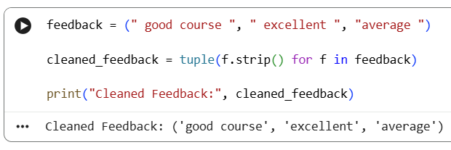
Challenge 4: combine student name and course
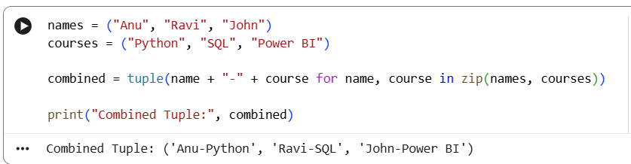
Challenge 5: extra email domains
